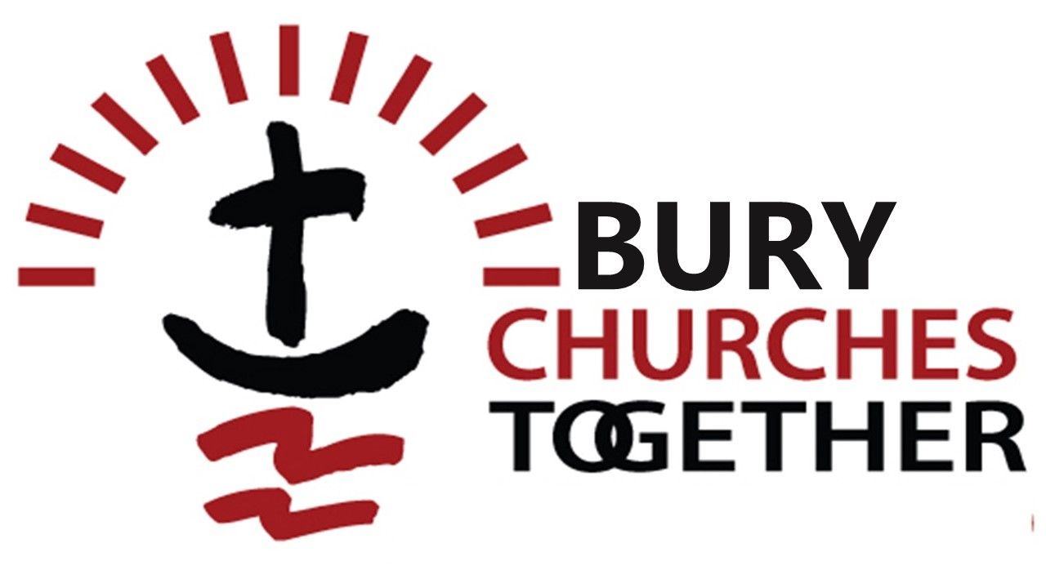

**Notes from  
Churches Together in Bury**

**following the meeting  
on 17th July**

David Somerville, joint chair, encouraged us to spend time like Mary listening to Jesus and not being too much of a Martha.

**Food Club and Drop in Cafe**

This is a new venture run by The Salvation Army. The Food Club is held on a Tuesday morning from 11am -2pm. There are volunteers from The Salvation Army and also from Bury Christian Fellowship. New people are waiting outside the door each week. Membership costs £5 and each week members can pay £3 for up to 15 items to a value of around £30. Out of date items are free. Volunteers are welcome.

The Drop in Cafe runs on a Thursday from 10.30 until 1pm. You can buy a toastie for £1. An Iranian lady is the volunteer chef. They are considering putting on a Christmas meal. About 23 people of several different nationalities have been coming. Please pray that these people will come together. The Salvation Army are now advertising for a paid part time community manager to run the club and cafe.

**Christmas Toy Collection**

Every year the Salvation Army run a Christmas toy appeal. Last year 700 referred families received gifts. However, in Bury this will not be able to run in 2024 unless another church is able to offer a large room for storing and sorting the items, from the beginning of November until mid December. Then a week would be needed to put all the items in bags for families. They only accept new unwrapped toys. Unless a church can offer the space by September this project will not be able to run this year. Please pray and consider whether there is a suitable space in your church.

**CAP**

Gordon Clark has been joined by a new debt coach, Jackie Cooke so they are again able to accept new clients. If you know anyone in need of debt counselling, this is a good time to refer them.

Bolton Road Methodist has now taken on this role of sponsoring church, following Bury Christian Fellowship. The trustees of the Bury Project are responsible for governance. Bolton Road will be holding a special CAP Sunday with speakers from head office on Sunday 8th September at 10.30am.

Over the past 3 years Gordon, together with Gordon Joyce and Tim Boaden, has visited 22 churches to talk about the Bury Project. The next visit will be to Radcliffe Road Baptist Church. 34 different churches have supported the project in some way: providing volunteers, offering premises, providing hampers at Christmas and Easter or financially. Gordon expressed his gratitude to them. The work can be intense and sometimes frustrating when clients drop out. 28 households have become debt free since the start of the project. Some keep in contact. Most clients are happy to accept prayer. One client recently expressed a wish to try church and Gordon pointed her towards a church around the corner from her home.

**Chaplaincy**

We are urged to continue to pray for the work of Tristan and Daniel and for Julian Wolstencroft, who has now joined them as a third chaplain, engaging with staff and shoppers in the Millgate Centre.

**Street Pastors**

Street Pastors have been working in Bury for 15 years. In that time chairs of the trustees have been Rod Fairbrother and Gordon Clark, who has now resigned. Two co-ordinators are moving out of the area. There is, therefore, a great need for new leadership and volunteers. Street Pastors were given an exciting new opportunity by the council to provide daytime paid street patrols. This was because the work they have been doing was very highly regarded by the council. Please pray for the resources to continue this valuable work.

**Carol singing**

Is again being planned in the Millgate Centre and looking for singers and musicians.

**Bury Christian Fellowship**

continues to worship on a Sunday morning at 10.30 am, upstairs in the Castle Building, opposite Bury Parish Church, following the sale of their building.

**Cygnet Hospital**

This is a mental health hospital, just off Bolton Road. Kathy Selby, Bolton Road Methodist Church is the only chaplain there. More are needed and especially next year when Kathy retires. Kathy says that it is very rewarding work.

**Night Shelter**

This will be providing a safe place for rough sleepers again, this coming winter. It is held in Bolton Road Methodist Church. More volunteers are needed.

**Bible Society Action Group**

Alan Thew is now chairing this group following the retirement of Rev Eric Ruehorn. They will be holding an event in Bury URC at 7.30pm on September 20th. There will be worship, a speaker from the Bible Society and a performance by our local Open the Book team. This team dramatises bible stories for assemblies in local schools and always welcome more volunteers.

**Wonderful Word**

St Peter's will be hosting a day conference called Wonderful Word on Saturday Oct 5th from 9.30-4.30. This is to increase our knowledge of the Bible. There will be three key speakers on “An overview of the Bible” “The Old Testament” and “The New Testament” Two of the speakers are lecturers at theological colleges. It is necessary to book a place.

**The Big Picnic in the Park**

On Saturday 29th June our local C of E churches held a family fun day in Clarence Park. It was great fun. Both church families and local families took part, including some Muslim families. It was great for getting together.

**Messy Church and Footprints**

St Paul's on the “Dickie Bird” estate run a monthly Messy Church and a weekly shorter after school service on Fridays. 10-15 families attend. They recently celebrated the baptism of two ladies, with another happening soon.

**Chinese Church**

There is a small Chinese Church in Bury, and also a Cantonese Church which meets at St Mary the Virgin. Please pray for these churches.